Assignment No 13

Using the UNION Clause

Q1) Write a union of two queries that shows the names, cities, and ratings of all customers. Those with rating of 200 or dreater will also have the words “HIGH RATING”, while the orders will have the words “LOW RATING”

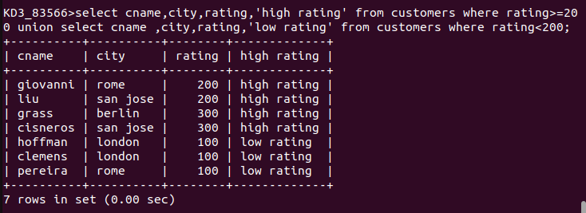

Q2) Write a command that produces the name and number of each salesperson and each customer with more than one current order. Put the results in alphabetical order.

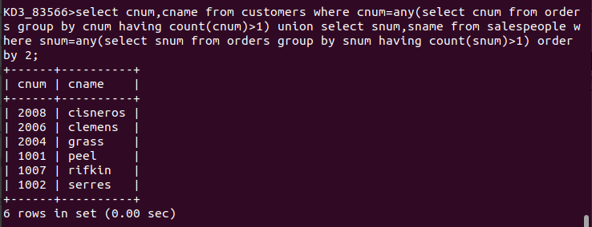
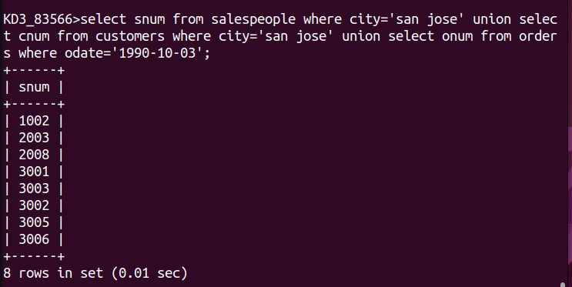
3)

